

**Obesity in Jordan:**

**A Comprehensive Study**

**Analytical Report**

Course: Data Visualization

Group Members:

* Yazan Hadi Anfoka 20200311
* Faris Al-Faori 20200454

Instructor: Amira Al-Amery

1. Executive Summary

Using a dataset containing information of over 900 Jordanians and their sleeping quality, their mental distress, their resilience, and basic information, we conducted a study about the different factors that affect and possibly correlate with obesity and its many stages.

The study had found several things: First, that the study had found that for the three major metrics of PSQI, BRS, and K10, there is no sufficient evidence to prove their correlation between them and obesity, surprisingly. Second, the main variable that had sufficient evidence to be correlated with obesity were as follows: Gender, age, smoking, physical activity time, family history of overweightness, and transportation method. Third and last, there was an interesting significant correlation between BRS & K10, which might invite a new study to delve in deeper.

2. Introduction

Obesity is a medical condition where an individual’s body has an unhealthy and large amount of fat within their body. This may lead to major medical complications and also may endanger the individual’s life.

This study has uncovered many factors and correlations that exist between these factors and the subject at hand by using various statistical tests to prove their correlations and summarizing the statistical descriptions of each important variable.

3. Discussion:

3.1 Main Statistical Variables:

Table 3.1.1 Main Numeric Variables Statistics

|  |  |  |  |  |  |
| --- | --- | --- | --- | --- | --- |
|  | Age | Physical Activity Time | PSQI | BRS | K10 |
| Min | 14 | 0.0 | 2 | 6 | 15 |
| 25% | 19 | 0.14 | 7 | 16 | 28 |
| 50% | 21 | 1.0 | 8 | 19 | 31 |
| 75% | 23 | 2.0 | 10 | 23 | 35 |
| Mean | 21.89 | 1.14 | 8.3 | 19.24 | 31.66 |
| Standard Dev. | 5.12 | 0.92 | 2.11 | 5.02 | 5.36 |
| Max | 41 | 3.0 | 16 | 30 | 48 |

Table 3.1.2 Main Variables Significant Correlations with Obesity

|  |  |  |  |  |  |  |
| --- | --- | --- | --- | --- | --- | --- |
|  | Age | Physical Activity Time | Smoke | Gender | Family History Overweight | Transportation |
| Cor % | 35% | -14% | 15% | 12% | 27% | 14% |
| P-Val | 2.2-e16 | 4.591-e6 | 0.0002 | 8.291-e6 | 2.2-e16 | 3.336-e8 |

3.2 Data Plots:

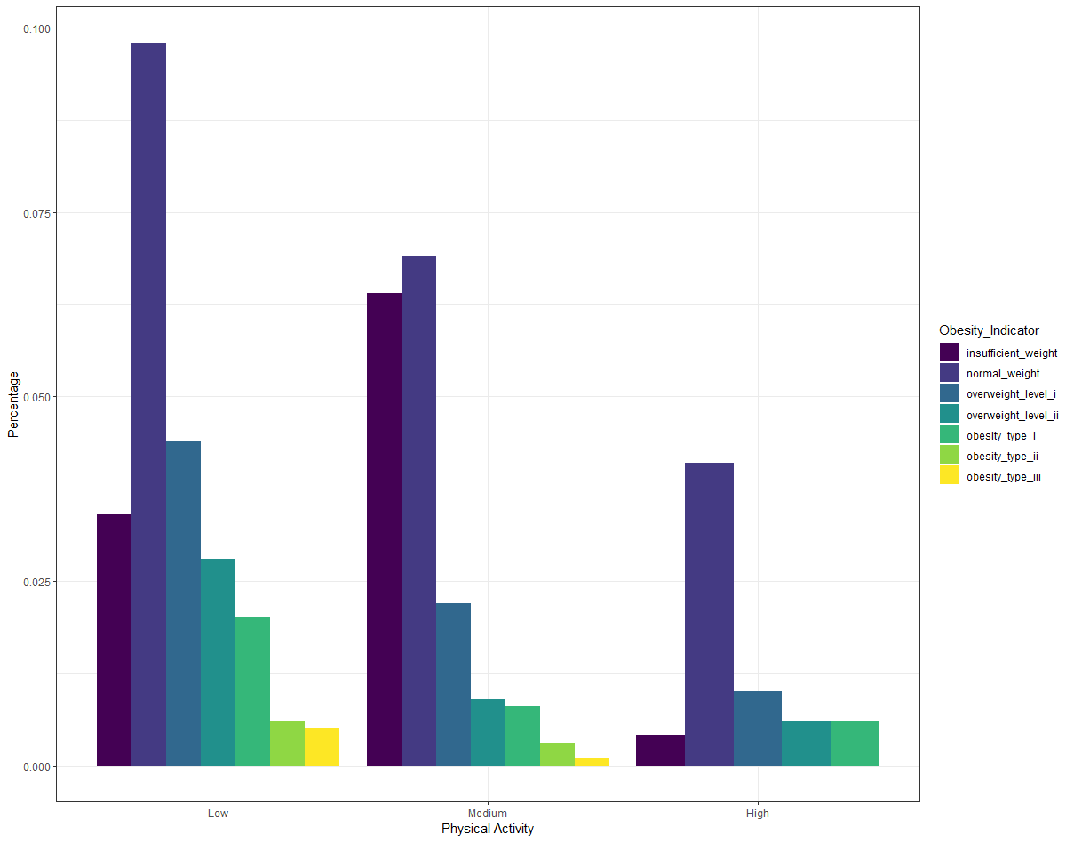

3.2.1 Histogram between Physical Activity and Obesity

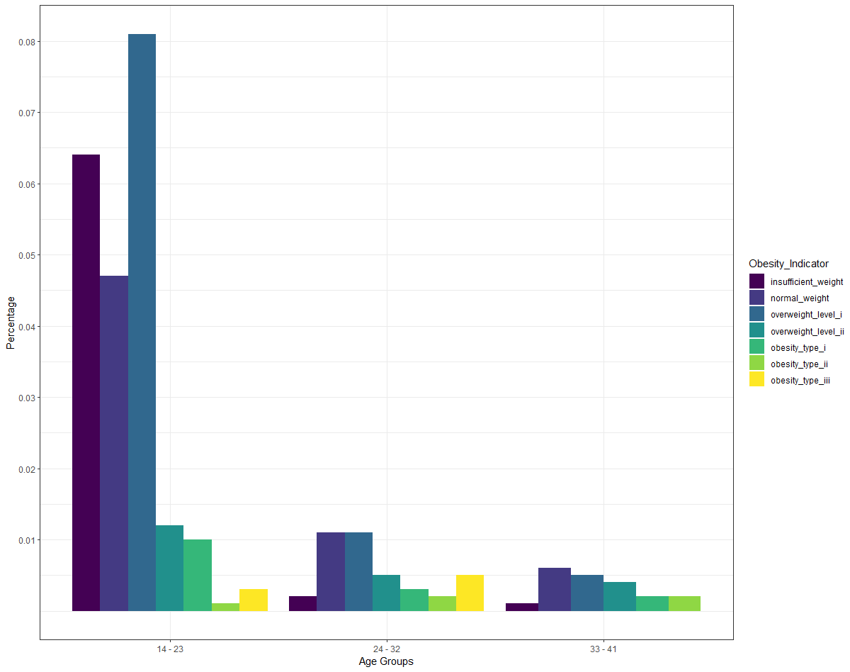

3.2.2 Histogram between Age and Obesity

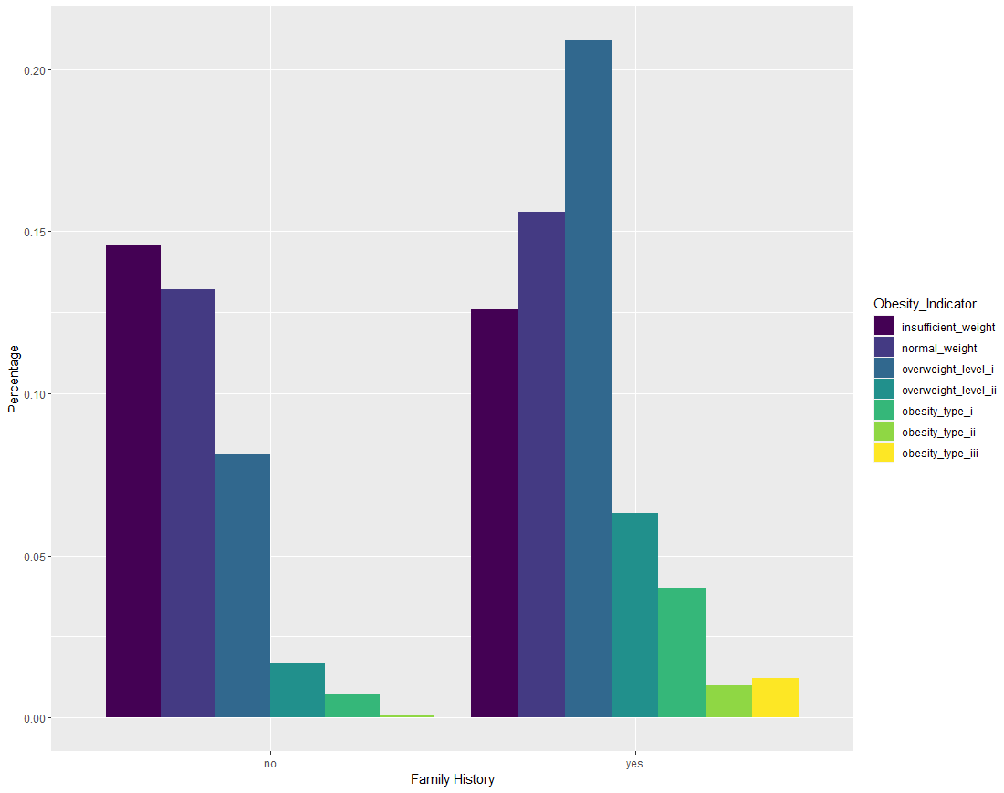

3.2.3 Histogram between Family History Overweight and Obesity

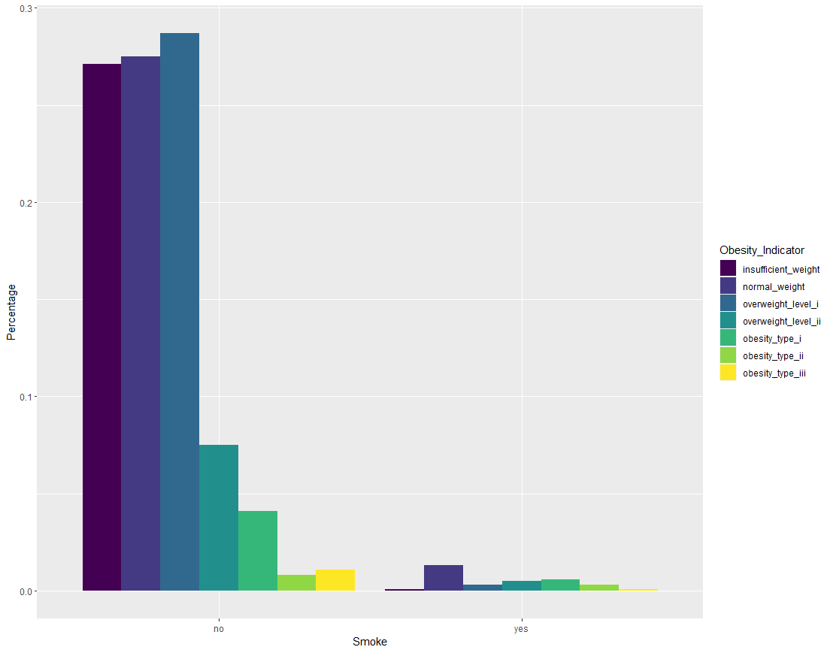

3.2.4 Histogram between Smoke and Obesity

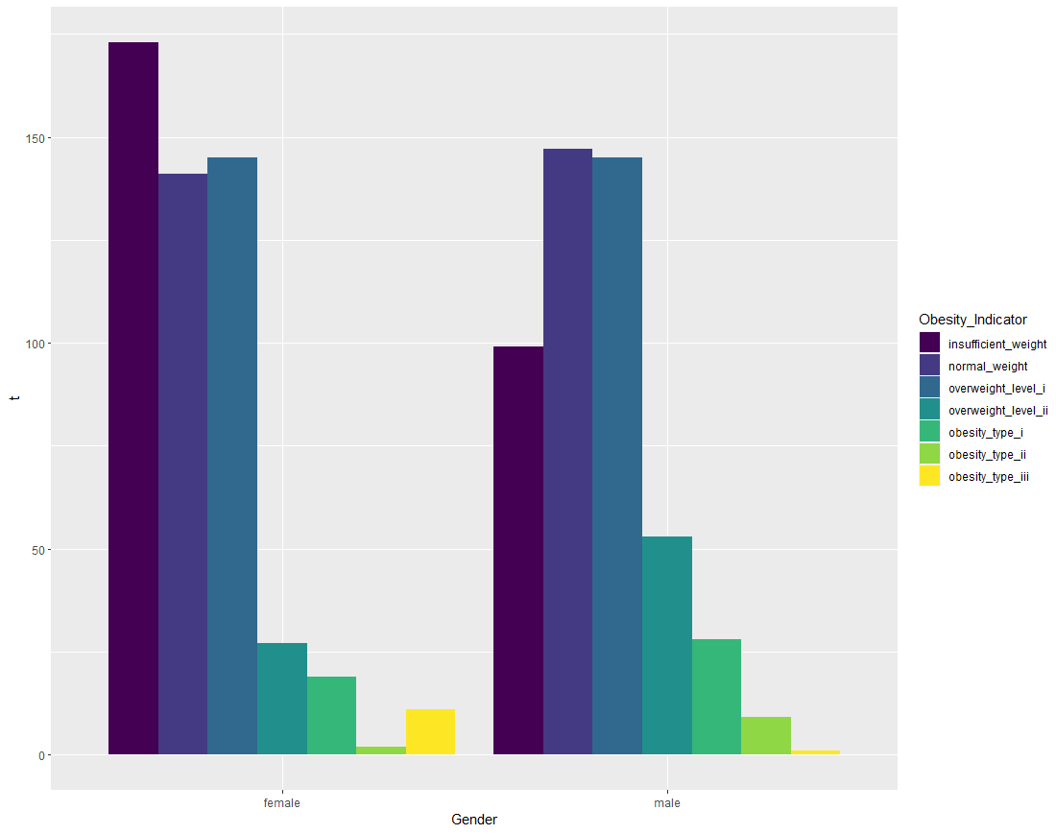

3.2.5 Histogram between Gender and Obesity

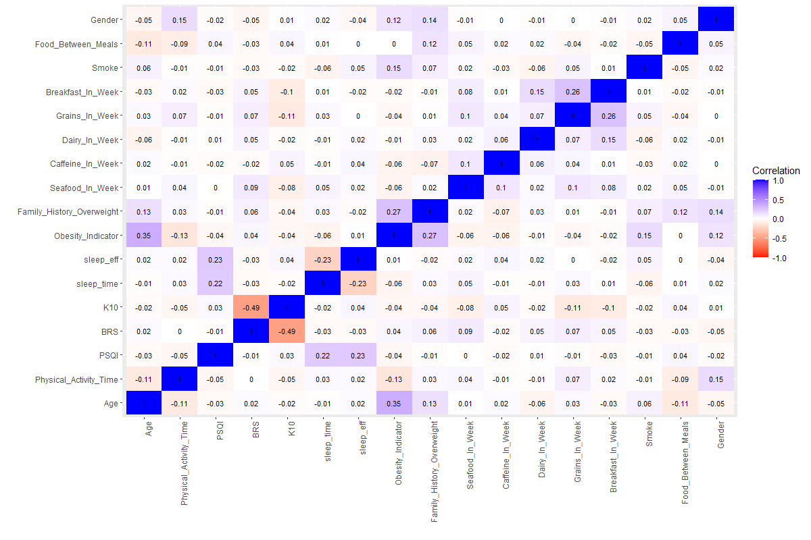

3.2.6 Correlation Heatmap

4. Recommendations & Further Work:

Given the visuals and tests, the following is recommended to decrease Jordan’s obesity rates: More exercise time, less smoking, walking and using pedaling bikes whenever possible for transport. Age, gender, and family history are immutable and so we cannot offer any advice to remedy them.

Given the negative correlation between physical exercise time and obesity, it’s natural that the more we exercise the less we risk obesity.

And because smoking has a positive correlation with obesity, we recommend to all to at least lessen the habit to lower the risk, though that should go without saying. For transportation, while the positive correlation means nothing, the test has shown there is a significant correlation between the two, and judging by the visuals, people should choose the more physically demanding modes of transport in order to combat obesity risk.

For any future work on this study, we recommend a cleaner and more filled dataset to obtain clearer observations of the possible correlations between the factors and obesity; the number of nulls and data entry errors have most likely tampered with the quality of inference.